1
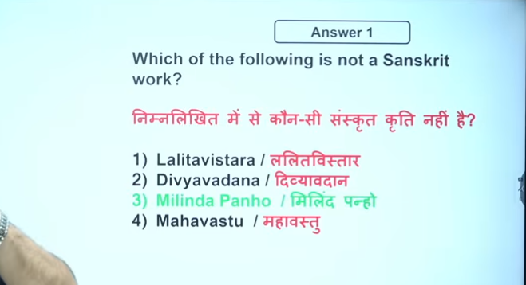
Pali Baudha Dharm

Milindapanho (or Milinda Panha), a foundational Pali text from the 1st/2nd century BC–AD, is a recorded dialogue written by the Buddhist sage Nagasena. It documents conversations on Buddhist philosophy, ethics, and metaphysics between Nagasena and the Indo-Greek King Menander I (Milinda) of Bactria.
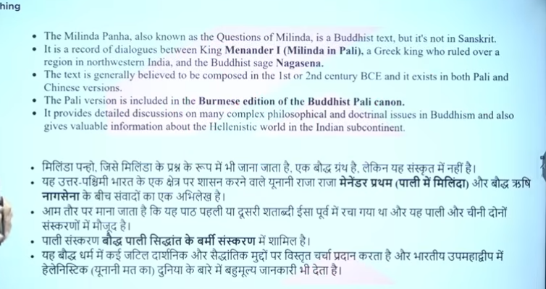
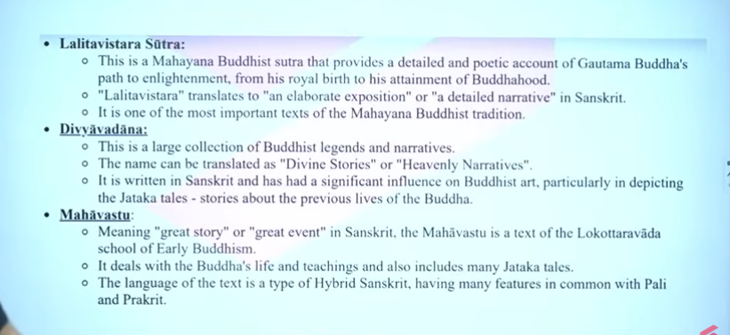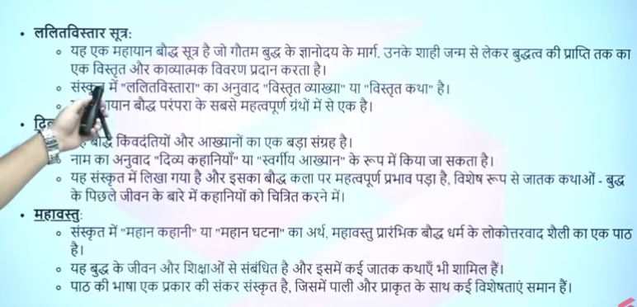

2

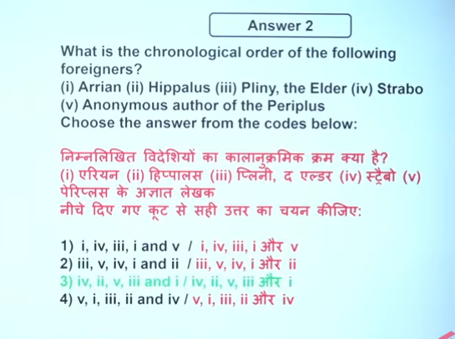
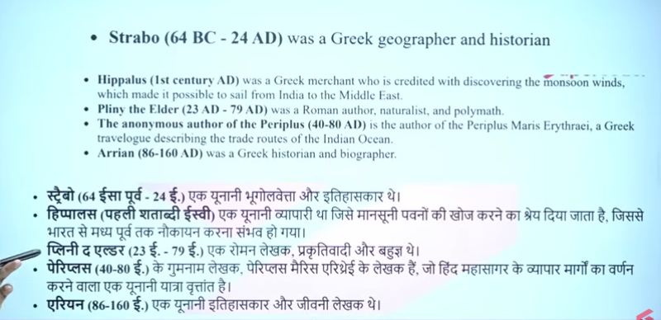

Strabo (64 BCE – 24 CE) was a Greek geographer and historian who documented the known world during the Roman Empire, crucial for UPSC Geography Optional and Ancient History. His 17-volume work, Geographica, is considered the foundation of regional geography and provided extensive, detailed descriptions of places, cultures, and physical environments.
Pliny the Elder (23AD–79 AD) was a Roman author and naturalist(prakativadi). famous for his encyclopedic work Naturalis Historia (Natural History), a crucial source for understanding Roman-Indian trade and ancient geography. He documented the massive drain of Roman gold to India for luxury goods, died observing the Vesuvius eruption.
The Periplus of the Erythraean Sea (c. 1st Century AD) is a crucial, anonymous Greek navigational text detailing Indo-Roman trade, written by an Egyptian Greek merchant. It is essential for UPSC Prelims/Mains, offering insights into maritime routes,, ports like Muziris and Arikamedu, and flourishing trade, including exports (spices, silk) and imports (wine, gold). The Periplus of the Erythraean Sea is a 1st-century CE Greek travelogue written by an anonymous Greek-speaking merchant or sailor based in Roman Egypt. It is a firsthand account of maritime trade routes, ports, and commodities connecting the Red Sea to India.
The "Maris Erthira" likely refers to the Periplus Maris Erythraei (Latin for "Voyage around the Erythraean Sea"), a 1st-century Greco-Roman text that provides a detailed first-hand account of trading routes and navigation along the Red Sea, the Horn of Africa, and the Indian Ocean.
- Meaning: "Erythraean Sea" was an ancient term for the Red Sea, Indian Ocean, and Persian Gulf

Yes, Arrian (Lucius Flavius Arrianus, c. 86–160 AD) was a prominent Greek historian, philosopher, and public servant during the 2nd-century Roman Empire. Born in Nicomedia (modern-day Turkey), he is best known for his "Anabasis of Alexander," which is considered one of the most reliable accounts of Alexander the Great's military campaigns.

3
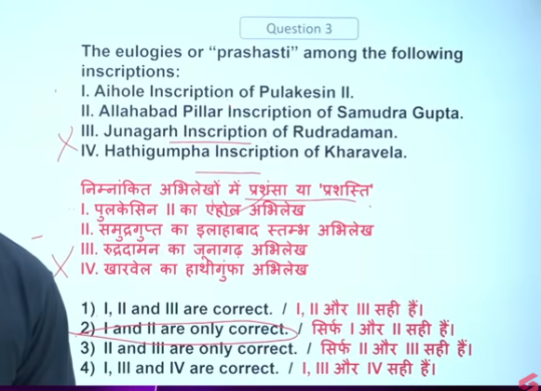

4
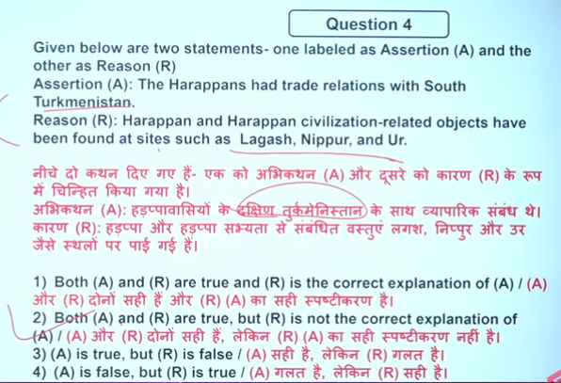
Lagas nipur and ur these are mesopotima sites

5
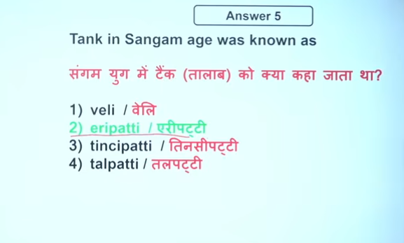
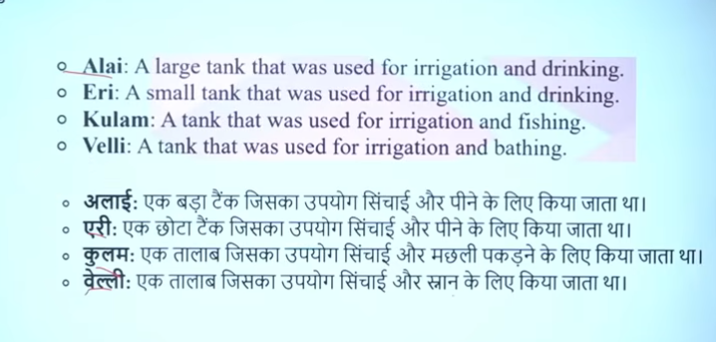

Eripatti refers to "land under a reservoir" or "tank land".
Eri means tank/reservoir, and "patti" means land. It refers to a "tank land".
Veli is a unit of land measurement.

1. The Sangam Institution
- Sangam/Muchchangam: The three assemblies (Academies) of Tamil poets and scholars, believed to have met under the Pandyan kings.
- Tolkappiyam: The earliest surviving Tamil grammatical work, which also provides insights into social life, written by Tolkappiyar.
- Aham (Interior): Literature focusing on emotions, love, and personal life.
- Puram (Exterior): Literature dealing with war, heroism, public life, and ethics.
- Pathinenkilkanakku: Eighteen minor didactic works (including the Thirukkural), often focusing on ethics.
- Silappathikaram & Manimegalai: The "Two Epics" or Twin Epics that describe the society and polity of the period.
2. Polity and Administration
- Muvendar: The "Three Crowned Kings"—the Cheras, Cholas, and Pandyas.
- Velir/Kurunila Mannar: Local chieftains who held authority over smaller territories.
- Ko/Mannan/Vendan/Korravan/Iraivan: Terms for the King.
- Aimperunkulu: The Five-member council that assisted the king (Ministers, Priests, Army Chiefs, Envoys, Spies).
- Enperayam: The Council of Eight members assisting the administration.
- Orrar/Vevu: Spies and the act of espionage.
- Mandalam: The entire kingdom.
- Nadu: The province or administrative division.
- Ur: A village or town.
- Pattinam: Coastal town/harbor area.

3. Geographical & Social Divisions (Tinais)
Sangam literature classifies the land into five ecological zones, or Tinais, each with distinct occupations and deities:
- Kurinji (Hilly): Mountains; inhabitants were Kuravar/Kanavar (hunters).
- Mullai (Pastoral): Forest/pastures; inhabitants were Ayar/Itaiyar (shepherds).
- Marudam (Agricultural): Plains; inhabitants were Ulavar/Toluvar (farmers).
- Neydal (Coastal): Coastal areas; inhabitants were Paratavar (fishermen/salt makers).
- Palai (Desert/Arid): Parched land; inhabitants were Maravar (warriors/robbers).
4. Society and Culture
- Arasar: The ruling class.
- Anthanar: Priests/Brahmins.
- Vanigar: Traders/merchants.
- Vellalar: Agriculturists.
- Panar/Viraliyar: Traveling bards and dancers (folk entertainers).
- Virakkal/Nadukal: Hero stones erected for fallen soldiers.
- Sati/Udankattai eruthal: Practice of self-immolation by widows.
- Kavalmaram/Kadimaram: A sacred tree in the palace symbolizing the king's power.
5. Economy
- Sungam/Ulgu: Tolls and customs duties.
- Kalam: Measure of grain.
- Ma/Veli: Measures of land.
- Irai/Karai: Land tax.
- Kalingam: A fine type of cotton cloth.

6
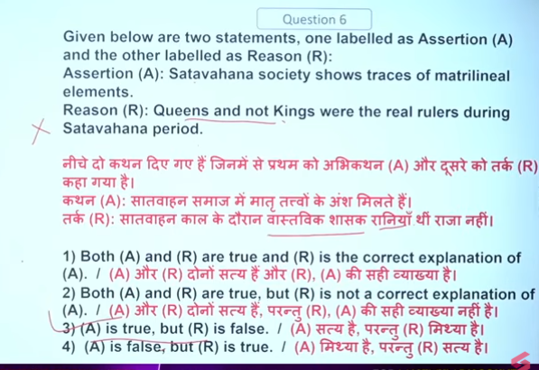

7
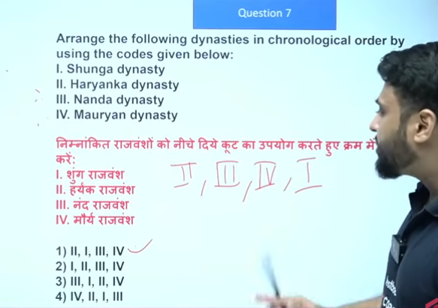
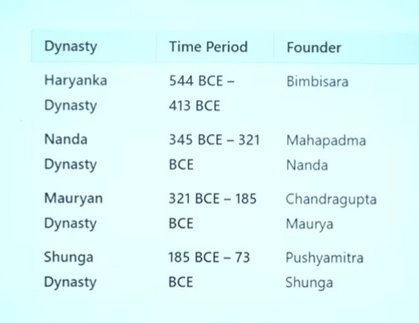

- Founder - Shishunaga (c. 413–345 BCE): Initially a 1amatya (official) of the Haryanka dynasty, he was installed on the throne by the people. He is credited with breaking the power of the Pradyota dynasty of Avanti, ending a long-running rivalry.
- Kanva dynasty : 73 BCE to 28 BCE Vasudeva Kanva, who was previously a minister to the Shunga Emperor Devabhuti.
- Satavahana Dynasty (also known as the Andhra dynasty) led by Simuka. mid-1st century BCE to the early 3rd century CE They reigned for over 200 years, establishing a major empire across the Deccan plateau.

8
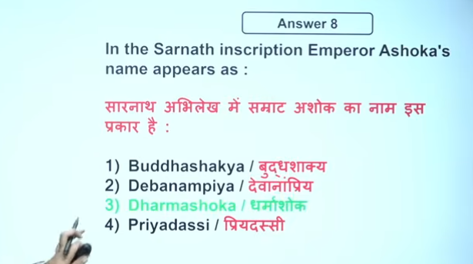

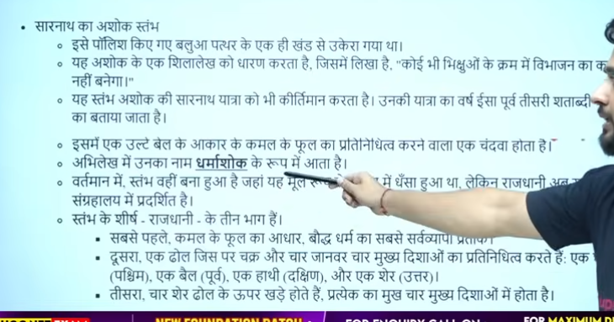

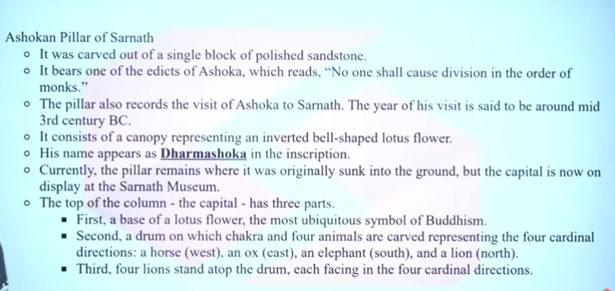

9

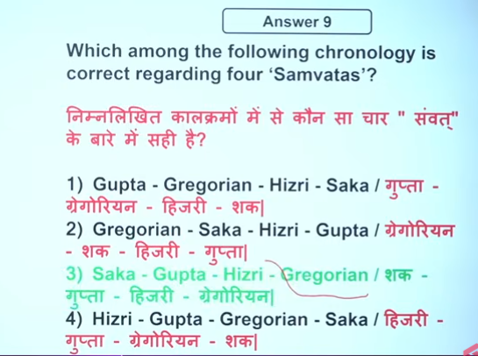
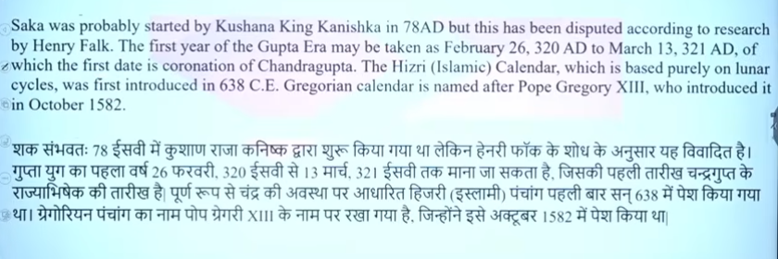

10
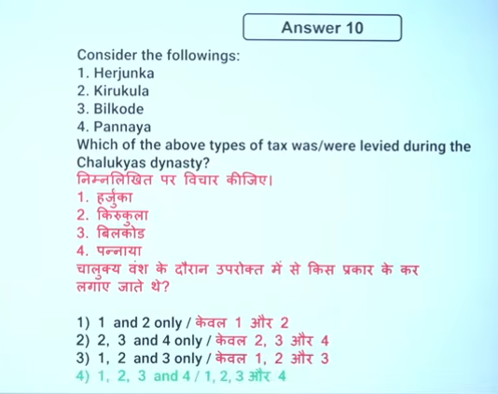
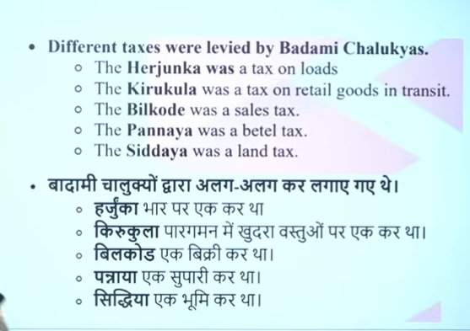

Q.11
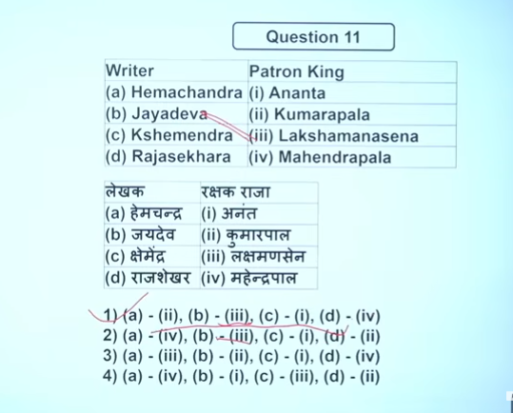

12
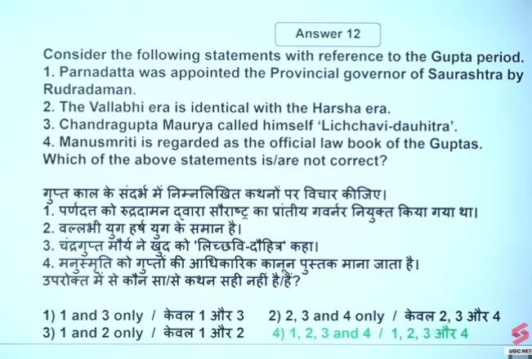

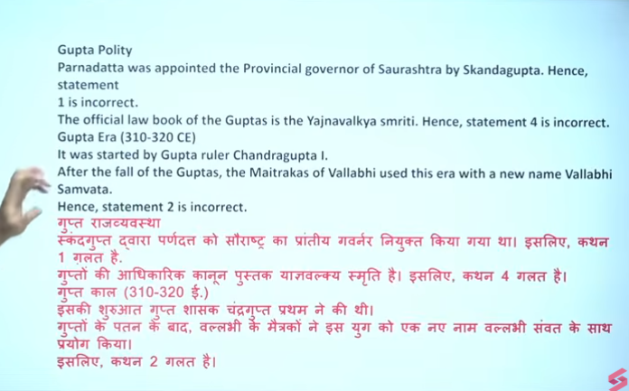

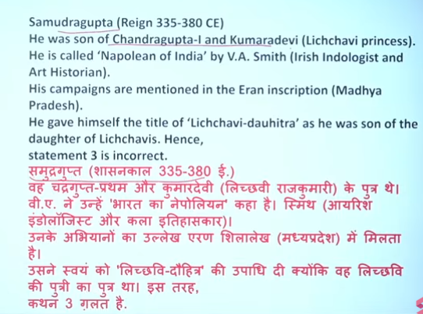

13
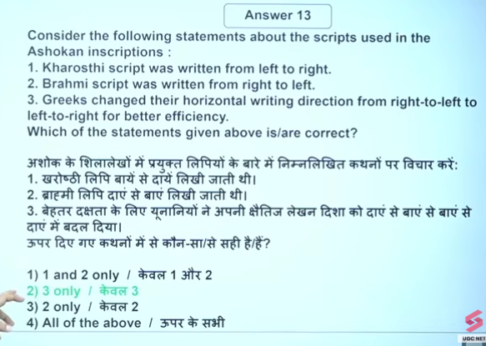
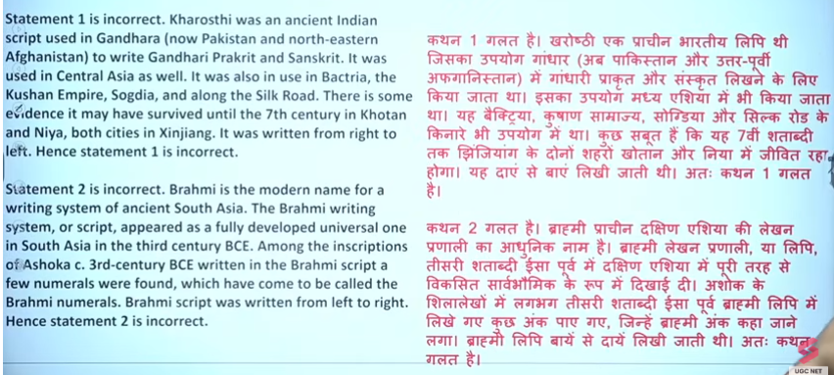
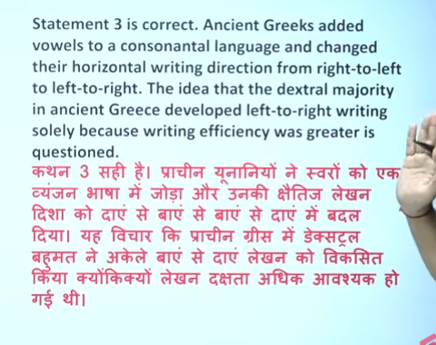

14
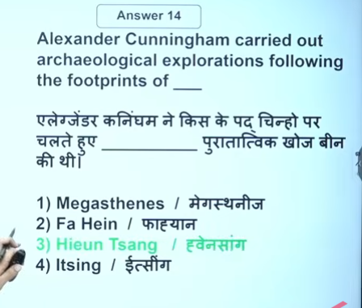
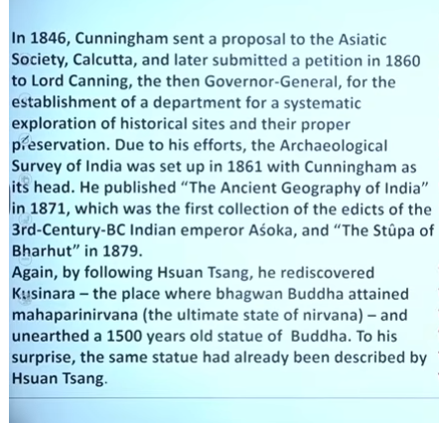
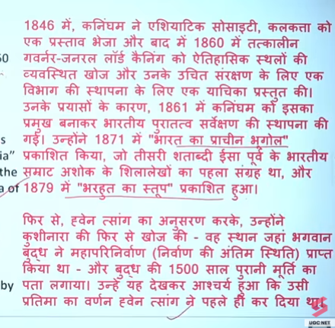

15
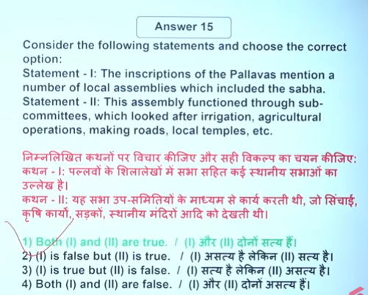
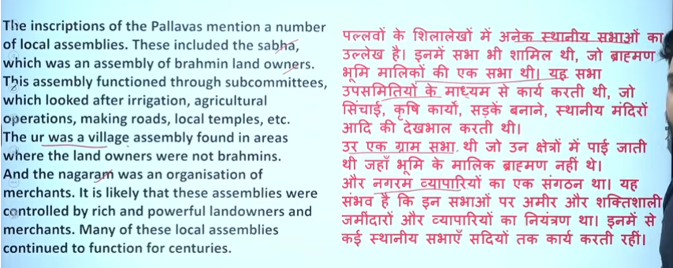
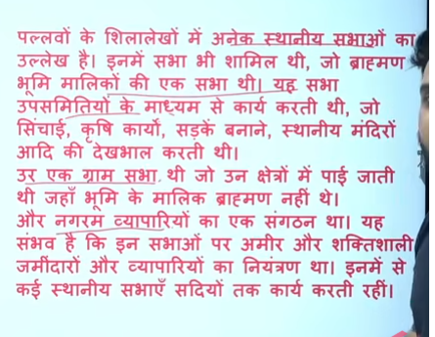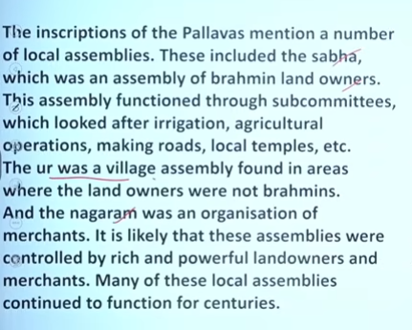

16
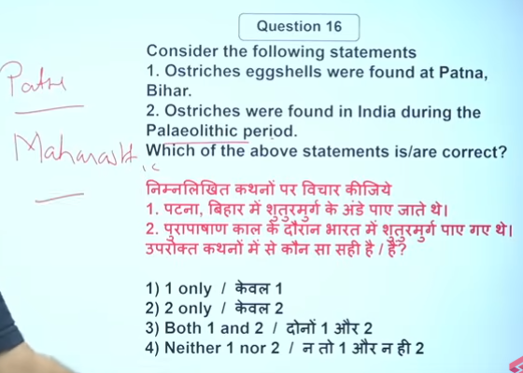

17
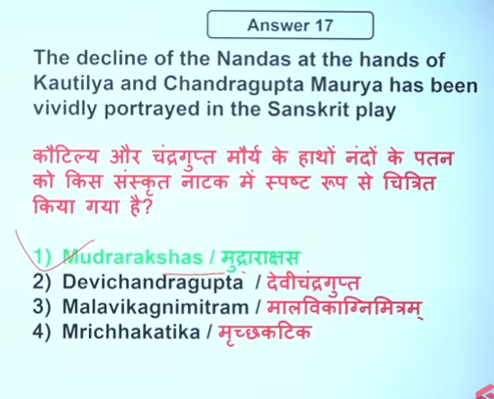

Q.18
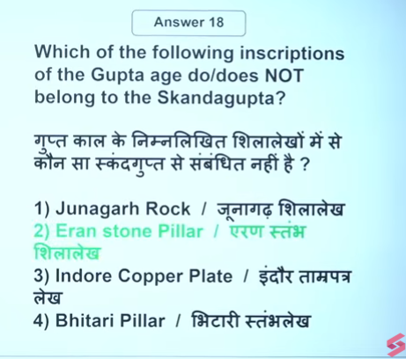
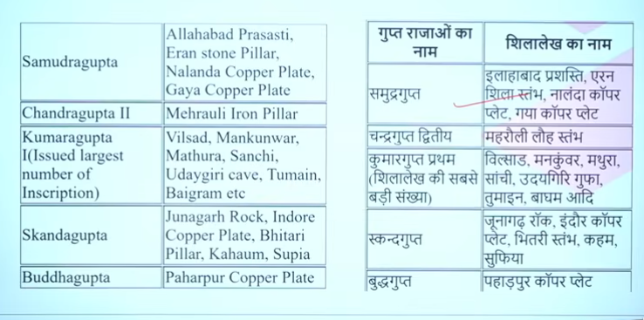

19
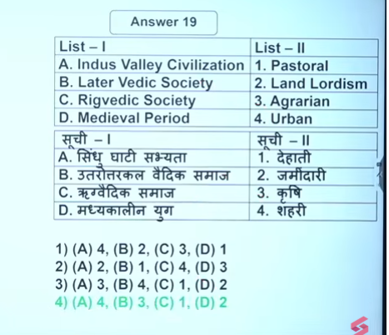

20
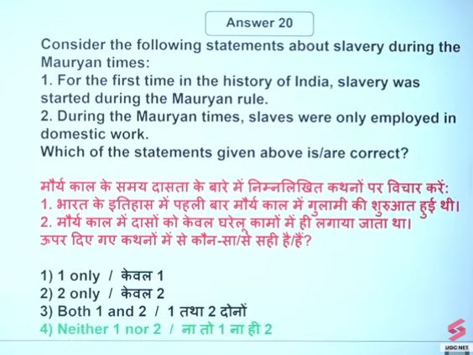

21
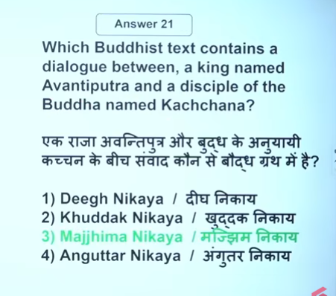
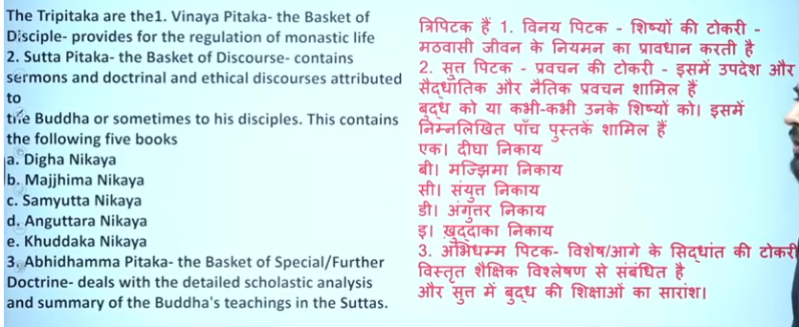

22
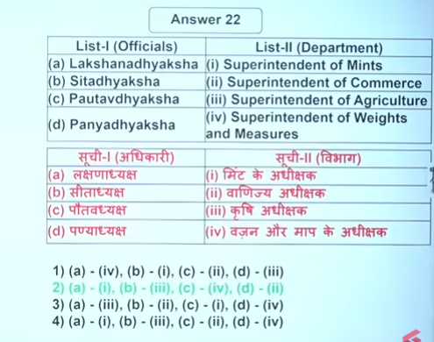

23
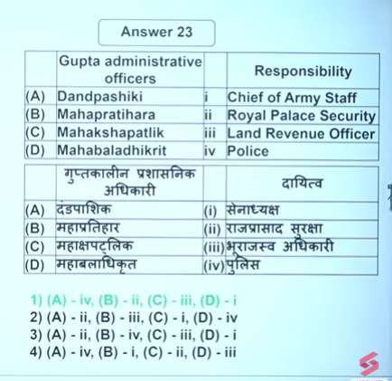

24
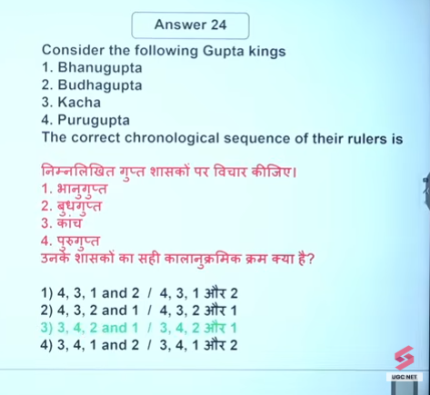
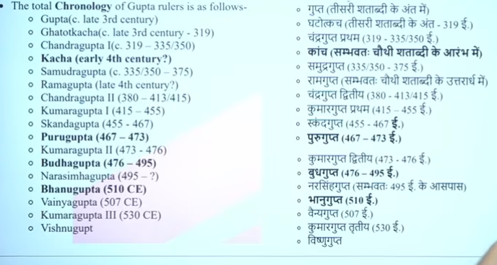

25
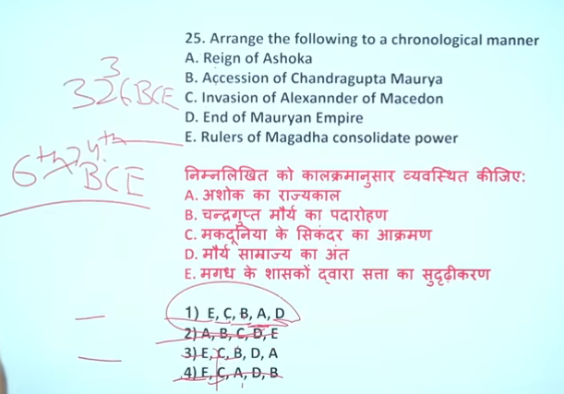
Around 321 BCE.

268 BCE to 232 BCE.
Accession of Chandragupta Maurya
- Year: Around 321 BCE.
- Chandragupta Maurya overthrew the last ruler of the Nanda Dynasty, Dhana Nanda, and established the Maurya Empire with the help of Chanakya.
Short UPSC point:
Chandragupta Maurya ascended the throne of Magadha in 321 BCE after defeating Dhana Nanda, marking the beginning of the Mauryan Empire.

Ashoka reigned from c. 268 BCE to 232 BCE.
He was the third ruler of the Maurya Empire and is famous for spreading Buddhism after the Kalinga War.
Ashoka was formally crowned after a succession struggle following the death of his father Bindusara. This struggle lasted from 273–269 BCE, and his coronation took place around 269–268 BCE at Pataliputra.
According to Sri Lankan traditions, he ascended the throne after four years of conflict. After his coronation, Ashoka expanded his empire and in the 8th year of his reign (261 BCE) he fought the Kalinga War.
Key Points about Ashoka’s Coronation
- Time: 269–268 BCE (coronation)
- Place: Pataliputra, capital of the Maurya Empire
- Succession struggle: After the death of Bindusara in 273 BCE, Ashoka fought with his brothers for the throne.
- Early rule: Initially known as “Chandashoka” (a cruel ruler), but after the Kalinga War in 261 BCE, he adopted Buddhism and the policy of Dhamma.
- Reign: Ashoka ruled from 268 BCE to 232 BCE.
After his coronation, Ashoka strengthened his position and expanded his empire across a large part of the Indian subcontinent, extending from Afghanistan in the northwest to Mysore in the south.

Alexander the Great did not invade Macedonia; rather, he was King of Macedon (336–323 BCE) who expanded its empire from Greece to India. Following his father Philip II, Alexander solidified Macedonian control over Greece before launching a massive, successful campaign in 334 BCE that conquered the Persian Empire.

The rulers of Magadha began consolidating power around the 6th century BCE, especially c. 544 BCE onward with the rule of Bimbisara. This period marks the start of Magadha’s expansion among the Mahajanapadas.
Timeline of Consolidation of Magadha Power
1. Bimbisara
- Reign: c. 544–492 BCE
- Dynasty: Haryanka Dynasty
- Key actions:
  - Conquered Anga
  - Used marriage alliances with Kosala, Lichchhavi, and Madra
  - Strengthened administration and trade
2. Ajatashatru
- Reign: c. 492–460 BCE
- Expanded Magadha further
- Defeated the Vajji Confederacy
- Built fortifications at Pataligrama
3. Udayin
- Reign: c. 460–444 BCE
- Founded Pataliputra
- Shifted capital from Rajagriha

Magadha rulers started consolidating power in the 6th century BCE (around 544 BCE) under Bimbisara.

